[Enter School Name]

Student Bullying Policy
Purpose: | The purpose of this policy is to protect students from bullying and to respond appropriately when bullying does occur at [enter school name]
Scope: | Students and employees, including full-time, part-time, permanent, fixed-term and casual employees, as well as contractors, volunteers and people undertaking work experience or vocational placements
References: | - Education (Accreditation of Non-State Schools) Regulation 2017 (Qld)  - Australian Education Act 2013 (Cth)  - Australian Education Regulation 2013 (Cth)  - Disability Discrimination Act 1992 (Cth)  - Human Rights and Equal Opportunity Commission Act 1986  - Racial Discrimination Act 1975 (Cth)  - Racial Hatred Act 1995 (Cth)  - Sex Discrimination Act 1984 (Cth)  - SDAS(SQ)Ltd Student Bullying Reporting and Response Procedures (SQS205.001.ADM)  - SDAS(SQ)Ltd Positive Behaviour Management Policy (SQS196.001.ADM)  - SDAS(SQ)Ltd Disability Discrimination Policy (SQS203.001.ADM)  - SDAS(SQ)Ltd Student Code of Conduct (SQS204.001.ADM)  - SDAS(SQ)Ltd Complaints and Dispute Resolution Policy (SQS193.001.ADM)  - SDAS(SQ)Ltd Complaints and Dispute Resolution Procedures (SQS194.001.ADM)
Status: | Approved |  | Supersedes: SQS195.001.EDU
Policy Owner: | Seventh-day Adventist School (South Queensland) Limited
Authorised by: | Chief Executive Officer |  | Date of Authorisation: 22 September 2020
Approved by: | This policy has been ratified by the Board of Directors of Seventh-day Adventist Schools (South Queensland) Limited as the Student Bullying Policy for Seventh-day Adventist Schools (South Queensland) Limited.  Pr Brett Townend  Board of Directors Chairperson: Date of Approval: 22/09/2020  Pr Colin Renfrew  Board of Directors Secretary: Date of Approval: 22/09/2020
Review Cycle: | Reviewed Biennially (every two years) |  | Next Review Date: Term 3 - 2022
Review Team: | Board of Directors, Chief Executive Officer, Project Officers, Principals
Revised by  Vanessa Woodman  (9 September 2020) | Section  References | Details of Changes  Updated Education (Accreditation of Non-State Schools) Regulation 2001 (Qld) to 2017
Vanessa Woodman  (9 September 2020) | Definitions | Updated the national definition of bullying from its source reference.

Policy Statement
Seventh-day Adventist Schools (South Queensland) Limited has a zero tolerance to bullying.
Seventh-day Adventist Schools (South Queensland) Limited is committed to taking action to protect students from bullying and to respond appropriately when bullying does occur.
In order to prevent bullying from occurring, Seventh-day Adventist Schools (South Queensland) Limited will implement the following actions:
- Raise awareness within each of the entities of Seventh-day Adventist Schools (South Queensland) Limited of what bullying is, how it impacts on people and how bullying is responded to at each school site;
- Ensure that programs and processes within each entity of Seventh-day Adventist Schools (South Queensland) Limited develop and promote effective social skills and positive relationships amongst students.
In order to respond appropriately to any incidences of bullying, Seventh-day Adventist Schools (South Queensland) Limited will ensure that each entity:
- Develops an appropriate mechanism for students and parents to report bullying;
- Educates students and parents on how to respond, in the first instance, to incidences of bullying, and how to then report all incidences of bullying;
- Educates employees on how to appropriately respond to reports of bullying;
- Investigates and act upon all reports of bullying;
- Takes appropriate action, which might include support for targets of bullying and perpetrators and/or disciplinary measures.
SDAS(SQ)Ltd Student Bullying Reporting and Response Procedures (SQS205.001.ADM) explains the bullying reporting mechanism for students and parents, and details how employees will respond to reports, including that all reports will be investigated and acted upon, with appropriate support and consequences implemented.

Definitions
The national definition of bullying for Australian schools is:
Bullying is an ongoing and deliberate misuse of power in relationships through repeated verbal, physical and/or social behaviour that intends to cause physical, social and/or psychological harm. It can involve an individual or a group misusing their power, or perceived power, over one or more persons who feel unable to stop it from happening.
Bullying can happen in person or online, via various digital platforms and devices and it can be obvious (overt) or hidden (covert). Bullying behaviour is repeated, or has the potential to be repeated, over time (for example, through sharing of digital records).
Bullying of any form or for any reason can have immediate, medium and long-term effects on those involved, including bystanders. Single incidents and conflict or fights between equals, whether in person or online, are not defined as bullying.
(Source: <https://bullyingnoway.gov.au/WhatIsBullying/DefinitionOfBullying>, accessed 9/9/2020)

Other useful definitions
- Bullying: is a systemic and repeated abuse of power. In general bullying may be defined as:
  - dominating or hurting someone;
  - unfair action by the perpetrator(s) and an imbalance of power;
  - a lack of adequate defence by the target and feelings of oppression and humiliation.
It can occur at any age, across cultures, genders and socioeconomic groups. It can happen in the playground, toilet areas, to and from school or in the classroom.
- Behaviours that do not constitute bullying include:
  - mutual arguments and disagreements (where there is no power imbalance);
  - not liking someone or a single act of social rejection;
  - one-off acts of meanness or spite;
  - isolated incidents of aggression, intimidation or violence.
- Physical bullying: this is when a person (or group of people) uses physical actions to bully, such as hitting, poking, tripping or pushing. Repeatedly and intentionally damaging someone's belongings is also physical bullying
- Verbal bullying: repeated or systematic name calling, insults, homophobic or racist remarks and verbal abuse
- Covert bullying: such as lying about someone, spreading rumours, playing a nasty joke that make the person feel humiliated or powerless, mimicking or deliberately excluding someone
- Psychological bullying: for example, threatening, manipulating or stalking someone
- Cyber bullying: using technology, such as email, mobile phones, chat rooms, social networking sites to bully verbally, socially or psychologically
- Supportive Bystander Behaviour: is when the actions of a supportive bystander can stop or diminish a specific bullying incident or help another student to recover from it. A bystander is someone who sees or knows about child maltreatment, harassment, aggression, violence or bullying that is happening to someone else. Supportive bystander behaviours are actions and / or words that are intended to support someone who is being attacked, abused or bullied.
- Restorative Discipline: a whole school approach to building school climate and addressing student behaviour that fosters belonging over exclusion, social engagement over control, and meaningful accountability over punishment.

Responsibilities

System Responsibilities
Seventh-day Adventist Schools (South Queensland) Limited acknowledges its responsibility to:
- Promote programs that raise awareness of bullying and how the schools will respond to it;
- Ensure that systems and processes are in place so that action is taken to prevent bullying;
- Develop and implement a reporting mechanism for students and parents;
- Support the education of students and parents on how to respond to bullying and how to report it;
- Oversee the education of employees on how to appropriately respond to bullying;
- Require the investigation of all reports of bullying, including the provision of appropriate support and consequences;
- Share the responsibility of systemically opposing all forms of bullying.

Principal Responsibilities
The school principals of Seventh-day Adventist Schools (South Queensland) Limited acknowledges their responsibility to:
- Raise awareness of bullying and how the school will respond to it;
- Take action to help prevent bullying;
- Implement a reporting mechanism for students and parents;
- Educate students and parents on how to respond to bullying and how to report it;
- Educate employees on how to appropriately respond to bullying;
- Investigate and act upon all reports of bullying, including providing appropriate support and consequences;
- Share the responsibility of taking an active stance against all forms of bullying and model appropriate behaviour.

Employee Responsibilities
Employees of Seventh-day Adventist Schools (South Queensland) Limited have a responsibility to:
- Uphold and consistently apply this Policy;
- Respond appropriately to reports of bullying, including investigating and acting upon reports of bullying, and by providing appropriate support and consequences in accordance with SDAS(SQ)Ltd Student Bullying Reporting and Response Procedures (SQS205.001.ADM) and SDAS(SQ)Ltd Positive Behaviour Management Policy (SQS196.001.ADM);
- Share the responsibility of taking an active stance against all forms of bullying and model appropriate behaviour.

Parent/Caregiver Responsibilities
Parents and caregivers of children enrolled at entities of Seventh-day Adventist Schools (South Queensland) Limited have a responsibility to:
- Encourage their child not to bully others;
- Encourage their child to report bullying to themselves, staff or others;
- Encourage their child to take steps to stop bullying as directed under this Policy, SDAS(SQ)Ltd Student Bullying Reporting and Response Procedures (SQS205.001.ADM) and SDAS(SQ)Ltd Positive Behaviour Management Policy (SQS196.001.ADM);
- Share the responsibility for taking an active stance against all forms of bullying and model appropriate behaviour;
- Understand that it is not appropriate for them to approach or contact either the parents or caregivers of other students, or the students themselves, regarding allegations of bullying.

Student Responsibilities
Students enrolled at entities of Seventh-day Adventist Schools (South Queensland) Limited have a responsibility to:
- Not engage in bullying behaviour towards others;
- Report bullying occurring to them or others;
- Take steps to stop bullying as directed under this Policy, SDAS(SQ)Ltd Student Bullying Reporting and Response Procedures (SQS205.001.ADM) and SDAS(SQ)Ltd Positive Behaviour Management Policy (SQS196.001.ADM);
- Share the responsibility of taking an active stance against all forms of bullying and model appropriate behaviour;
- Understand that it is not appropriate for them to remain a bystander when they aware that bullying is occurring.

Implementation
Seventh-day Adventist Schools (South Queensland) Limited is committed to developing and maintaining a zero-tolerance approach to bullying at each of its educational entities, including by the development and implementation of this policy and related procedures, and via the clear support and promotion of the policy, procedures and support documents.
Seventh-day Adventist Schools (South Queensland) Limited is also committed to appropriately training all employees on how to take reasonable steps to respond, investigate and act upon all reports and allegations of bullying. Entities of Seventh-day Adventist Schools (South Queensland) Limited will be required to keep appropriate records of all reports and incidences of bullying, including action taken and consequences implemented (refer to Documentation of Allegation or Incident on page 6 of this document).
The individual educational entities of Seventh-day Adventist Schools (South Queensland) Limited will act to encourage students, parents and employees to contribute to a healthy school culture through the promotion of each campus as having a zero-tolerance approach to bullying.

Investigation of Allegation or Incident
Once reported, the bullying allegation or incident will be investigated by the appropriate member of staff as required (i.e. teacher or leadership team member). The investigation will afford all those involved natural justice and will treat all parties involved with respect and support. Parents and caregivers will be notified of incidents involving their children as soon as practical.

Consequences of Allegation or Incident
Whilst any discipline outcome for the students who perpetrated the bullying will include appropriate consequences, they will also be supported through a process of restorative discipline that mends relationships and identifies strategies for maintaining more appropriate behaviours in the future. However, it must be acknowledged that repeated or extreme cases of bullying will be managed as per SDAS(SQ)Ltd Serious Discipline Policy (SQS004.001.EDU), which may lead to the perpetrator being stood-down, suspended, excluded and/or expelled.
It is also a priority to support those impacted by the bullying behaviour, including opportunities to discuss strategies that will assist them in dealing with any future situations. Ongoing monitoring of individuals will be allocated to an appropriate staff member.
Parents or caregivers will be notified of the outcome of the bullying allegations involving their child. It is inappropriate for any staff member to discuss specific consequences with anyone other than that child’s parents or caregivers.

Documentation of Allegation or Incident
All allegations and incidents of bullying will be documented as pastoral care notes in SEQTA Teach. The pastoral care entry will only include the information of the initial allegation regarding the bullying incident. This pastoral care entry can be later updated within SEQTA to reflect the outcome of the investigation. The details entered into the pastoral care note must include the:
- Date and time of the alleged incident of bullying;
- Location that the bullying allegedly took place (e.g. playground, classroom, toilets, bus, verandah etc…);
- Type of bullying that allegedly occurred (e.g. physical, verbal, covert, psychological, cyber etc…);
- Names of the students who were the alleged perpetrators of the bullying, recipients of the alleged bullying and those who were bystanders during the alleged;
- Outcome of the investigation into the allegation;
- Consequences and support plan for each of the students involved, including detail regarding the notification of parents or caregivers;
- Plans to review the ongoing behaviour and interactions of the students involved, including details about the staff member who will undertake the future monitoring.

Compliance and Monitoring

Each entity that is part of Seventh-day Adventist Schools (South Queensland) Limited will need to take reasonable steps to increase awareness of bullying and its consequences through:

- Awareness - regularly raise awareness of bullying with staff, parents and students via the clear support and promotion of SDAS(SQ)Ltd Student Bullying Reporting and Response Procedures (SQS205.001.ADM) and SDAS(SQ)Ltd Positive Behaviour Management Policy (SQS196.001.ADM) by the school board and executive management team;
- Training staff - regularly educate and train employees (especially senior staff) appropriately on how to prevent and manage bullying;
- Instructing students – how to identify what bullying is and is not and that in the first instance to report directly to their classroom teacher;
- Dispute resolution - awareness, promotion and implementation of the SDAS(SQ)Ltd Complaints and Dispute Resolution Policy and Procedures (SQS193.001.ADM);
- Record keeping, monitoring, reporting - keep appropriate records, monitor and report on bullying issues;
- Contact the Chief Executive Officer of Seventh-day Adventist Schools (South Queensland) Limited - to provide confidential and impartial advice about the school’s local systems, processes and procedures with regards to bullying behaviour;
- Culture - removal of any discriminatory or offensive materials, rules and practices, and encouragement of employees and students to contribute to a healthy school culture.

Resources
Australian Education Authorities, 2020, Bullying. No Way!, <www.bullyingnoway.gov.au >
Australian Government Department of Education, 2017, Student Wellbeing Hub, <https://studentwellbeinghub.edu.au/glossary#/>, accessed 16 May 2018
Department of Education and Skills (Ireland), 2013, Anti-Bullying Procedures for Primary and Post-Primary Schools, <https://www.education.ie/en/Publications/Policy-Reports/Anti-Bullying-Procedures-for-Primary-and-Post-Primary-Schools.pdf#page=8>, p42, (accessed 20 February 2018 – practical tips for building a positive school culture and climate)
Department of Education and Training, 2017, The National Safe Schools Framework,
<https://www.education.gov.au/national-safe-schools-framework-0 >
Kids Help Line, 2017, <http://www.kidshelp.com.au/>
Queensland Department of Education and Training, 2018, Preventing bullying and violence,
<http://behaviour.education.qld.gov.au/bullying-and-violence/Pages/default.aspx>
Queensland Department of Education and Training, 2018, Resources,
<http://behaviour.education.qld.gov.au/bullying-and-violence/schools/Pages/resources.aspx>

Appendix
For more information on how schools can respond to student bullying, see flow chart in Appendix A.

Appendix A
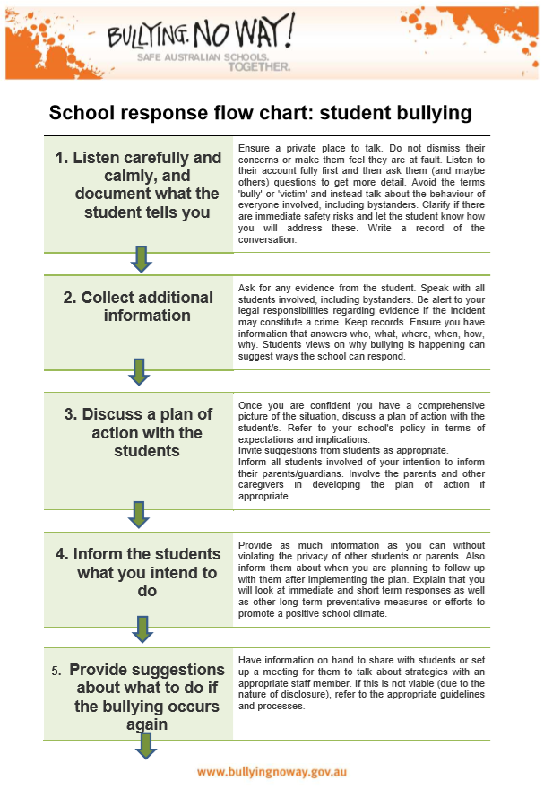

Appendix A
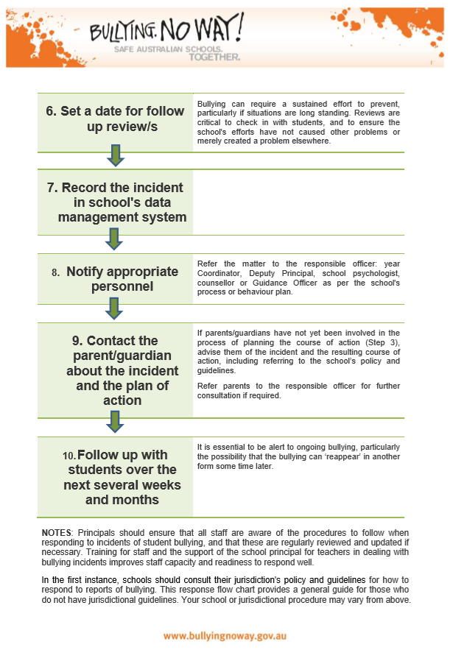

Bullying. No Way!, 2020, Definition of Bullying, < https://bullyingnoway.gov.au/WhatIsBullying/DefinitionOfBullying>, accessed 9 September 2020

