[Enter School Name]

Notifiable Data Breaches Policy
Purpose: | The purpose of this policy is to ensure that Seventh-day Adventist Schools (South Queensland) Limited is compliant with the Notifiable Data Breaches (NDB) scheme under Part IIIC of the Privacy Act 1988 (Privacy Act). Entities of Seventh-day Adventist Schools (South Queensland) Limited have data breach notification obligations when a data breach is likely to result in serious harm to individuals whose personal information is involved in the breach.
Scope: | Students and employees, including full-time, part-time, permanent, fixed-term and casual employees, as well as contractors, volunteers and people undertaking work experience or vocational placements, where personal information is stored about these individuals
References: | - Privacy Amendment (Notifiable Data Breaches) Act 2017  - Privacy Act 1988 (Cth)  - SDAS(SQ)Ltd Privacy Policy (SQS130.003.ADM)  - OAIC - Data breach preparation and response: A guide to managing data breaches in accordance with the Privacy Act 1988 (Cth). Updated July 2019
Status: | Approved |  | Supersedes: SQS201.001.ADM
Policy Owner: | Seventh-day Adventist Schools (South Queensland) Limited
Authorised by: | Chief Executive Officer |  | Date of Authorisation: 22 September 2020
Approved by: | This policy has been ratified by the Board of Directors of Seventh-day Adventist Schools (South Queensland) Limited as the Notifiable Data Breaches Policy for Seventh-day Adventist Schools (South Queensland) Limited.  Pr Brett Townend  Board of Directors Chairperson Date of Approval: 22/09/2020  Pr Colin Renfrew  Board of Directors Secretary Date of Approval: 22/09/2020
Review Cycle: | Reviewed Biennially (every two years) |  | Next Review Date: Term 3 - 2022
Review Team: | Board of Directors, NSSAB, Chief Executive Officer, Project Officers
Revised by  Steve Cowley  (26 March 2018) | Section  Whole document | Details of Changes  As per BoD ‘flying minute’ of 26 February 2018:  - document status changed from ‘Draft’ to ‘Approved’  - issue and approval dates changed to 26 February 2018  - names of BoD Chairperson and Secretary added  - SDASSQ changed to SDAS(SQ)Ltd
Steve Cowley  (6 April 2018) | Whole document | As per email from Jack Ryan 5 April 2018, changed Education Director and Chief Education Director titles to Chief Executive Officer
Vanessa Woodman  (7 September 2020) | Whole document | Updated references to the OAIC Data Breach Notification Guide to the Data breach preparation and response: A guide to managing data breaches in accordance with the Privacy Act 1988 (Cth). Updated July 2019

Overview
Seventh-day Adventist Schools (South Queensland) Limited is committed to ensuring that any personal information that it holds regarding students, parents, employees or volunteers will be stored securely in accordance with the guidelines from the Office of the Australian Information Commissioner and the existing personal information security obligations under the Australian Privacy Act 1988 (Privacy Act).
The passage of the Privacy Amendment (Notifiable Data Breaches) Act 2017 established the Notifiable Data Breaches (NDB) scheme in Australia. The NDB scheme applies to all agencies and organisations with existing personal information security obligations from 22 February 2018.
Seventh-day Adventist Schools (South Queensland) Limited acknowledges the right of students, parents, employees and volunteers to reasonably expect that its entities will comply with the NDB with regards to investigation, containment, notification, assessment and review with regards to any identified data breaches. Further, it recognises that the NDB scheme strengthens the protections afforded to everyone’s personal information and improves transparency in the way that organisations respond to serious data breaches.

Which Data Breaches Require Notification?
An ‘eligible data breach’, which triggers notification obligations, is a data breach that is likely to result in serious harm to any of the individuals to whom the information relates. A data breach occurs when personal information held by an organisation is lost or subjected to unauthorised access or disclosure. Examples of a data breach include when:
- a device containing personal information is lost or stolen;
- a database containing personal information is hacked;
- personal information is mistakenly provided to the wrong person.
For more information, refer to the following support documents from the Office of the Australian Information Commissioner (OAIC):
- Data breach preparation and response: a guide to managing data breaches in accordance with the Privacy Act 1988 (Cth) (July 2019)
- Identifying Eligible Data Breaches (December 2017)

Assessing Suspected Data Breaches
Any entity of Seventh-day Adventist Schools (South Queensland) Limited that suspects an eligible data breach may have occurred must undertake reasonable and expeditious assessment to determine if the data breach is likely to result in serious harm to any individual affected.
For more information, refer to the following support documents from the Office of the Australian Information Commissioner (OAIC):
- Assessing a Suspected Data Breach (December 2017)

How to Notify
When an entity of Seventh-day Adventist Schools (South Queensland) Limited is aware of reasonable grounds to believe an eligible data breach has occurred, they are obligated to promptly notify individuals at likely risk of serious harm. The Office of the Australian Information Commissioner must also be notified as soon as practicable through a statement about the eligible data breach.
The notification to affected individuals and the Commissioner must include the following information:
- the identify and contact details of the organisation;
- a description of the data breach;
- the kinds of information concerned; and,
- recommendations about steps individuals should take in response to the data breach.
For more information, refer to the following support documents from the Office of the Australian Information Commissioner (OAIC):
- Data breach preparation and response: A guide to managing data breaches in accordance with the Privacy Act 1988 (Cth) – Part 4 - Notifying Individuals about an Eligible Data Breach (July 2019)

Responsibilities

System Responsibilities
Seventh-day Adventist Schools (South Queensland) Limited acknowledges its responsibility to ensure the secure storage of personal information in accordance with Privacy Act 1988 (Privacy Act) and the obligation to notify individuals as per the Privacy Amendment (Notifiable Data Breaches) Act 2017 and will undertake the following steps as part of that system governance:
- Develop, implement, promote and act in accordance with the SDAS(SQ)Ltd Notifiable Data Breaches Policy (SQS201.002.EDU);
- Ensure that appropriate support is provided to all parties regarding training and procedures for keeping personal information safe and secure as per the OAIC Guide to Securing Personal Information (June 2018);
- Receive from Seventh-day Adventist Schools (South Queensland) Limited entities reports of suspected or known data breaches;
- Take appropriate action to support the entity as they inform individuals of any eligible data breach;
- Complete the Notifiable Data Breach Form online to inform the Office of the Australian Information Commissioner on behalf of the entity.

School Responsibilities
The education entities of Seventh-day Adventist Schools (South Queensland) Limited acknowledges their responsibility to ensure the secure storage of personal information in accordance with Privacy Act 1988 (Privacy Act) and the obligation to notify individuals as per the Privacy Amendment (Notifiable Data Breaches) Act 2017 and will undertake the following steps as part of their compliance:
- Implement, promote and act in accordance with the SDAS(SQ)Ltd Notifiable Data Breaches Policy (SQS201.002.EDU);
- Appropriately communicate the SDAS(SQ)Ltd Notifiable Data Breaches Policy (SQS201.002.EDU) to students, parents and employees;
- Upon identification of a suspected or known data breach, assess the data breach in accordance with the process prescribed in OIAC Identifying Eligible Data Breaches (December 2017) and OAIC Assessing a Suspected Data Breach (December 2017);
- Take steps to reduce any potential harm to individuals, such as recovering the lost information before it is accessed;
- As a result of the investigation, notify eligible data breaches to Seventh-day Adventist Schools (South Queensland) Limited through the Chief Executive Officer;
- With the support of the Chief Executive Officer, notify the individuals impacted by the breach of their data with reference to OAIC Data breach preparation and response: A guide to managing data breaches in accordance with the Privacy Act 1988 (Cth) – Part 4 - Notifying Individuals about an Eligible Data Breach (July 2019)
- Review the incident and take action to prevent further breaches.

Implementation
Seventh-day Adventist Schools (South Queensland) Limited is committed to raising awareness of the importance of maintaining personal information in a safe and secure manner at each of its educational entities, including by the development and implementation of this policy, related procedures and OAIC support documents, and via the clear support and promotion of the policy, procedures and support documents.
Seventh-day Adventist Schools (South Queensland) Limited is also committed to appropriately training relevant employees (especially senior staff) on how to take reasonable steps to handle personal information in accordance with the Privacy Act 1988 (Privacy Act).
Seventh-day Adventist Schools (South Queensland) Limited will keep appropriate records of NDBs, will monitor NDBs and their resolution and will report on a high-level basis to the Board of Directors on NDB resolutions at each of its educational entities.
The individual educational entities of Seventh-day Adventist Schools (South Queensland) Limited will act to encourage students, parents and employees to contribute to a healthy school culture through the promotion of protecting personal information from misuse, interference and loss, and from unauthorised access, modification or disclosure.

Compliance and Monitoring

Each school that is part of Seventh-day Adventist Schools (South Queensland) Limited will need to take reasonable steps to handle personal information in accordance with the Australian Privacy Principles (APP):

- Consider whether to collect personal information – only collect personal information that is reasonably necessary to carry out your functions or activities. Over-collection can increase risks for the security of personal information;
- Privacy by design – you will be better placed to meet your personal information security obligations if you embed them early, as robust internal personal information handling practices, procedures and systems can assist you to embed good personal information handling practices and respond effectively in the event a privacy breach occurs;
- Assessing the risks – conduct a privacy impact assessment, an information security risk assessment and reviews of your personal information security controls so that you are aware of the variety of security risks you face, including threats and vulnerabilities, along with the possible impacts before designing and implementing your personal information security framework;
- Take appropriate steps and put into place strategies to protect personal information – consider what appropriate security measures are required to protect the personal information with regards to all of the entity’s acts and practices;
- Destroy or de-identify personal information – take reasonable steps to destroy or de-identify the personal information that was once held but is no longer needed for any purpose.

For more information on compliance and monitoring, refer to OAIC Guide to Securing Personal Information (June 2018).

Additional Resources from OAIC
- OAIC - Data breach preparation and response: A guide to managing data breaches in accordance with the Privacy Act 1988 (Cth). Updated July 2019

Appendix A
- OAIC - Data breach preparation and response: A guide to managing data breaches in accordance with the Privacy Act 1988 (Cth). Updated July 2019 – PART 3

Appendix B
https://forms.business.gov.au/smartforms/servlet/SmartForm.html?formCode=OAIC-NDB

Appendix A
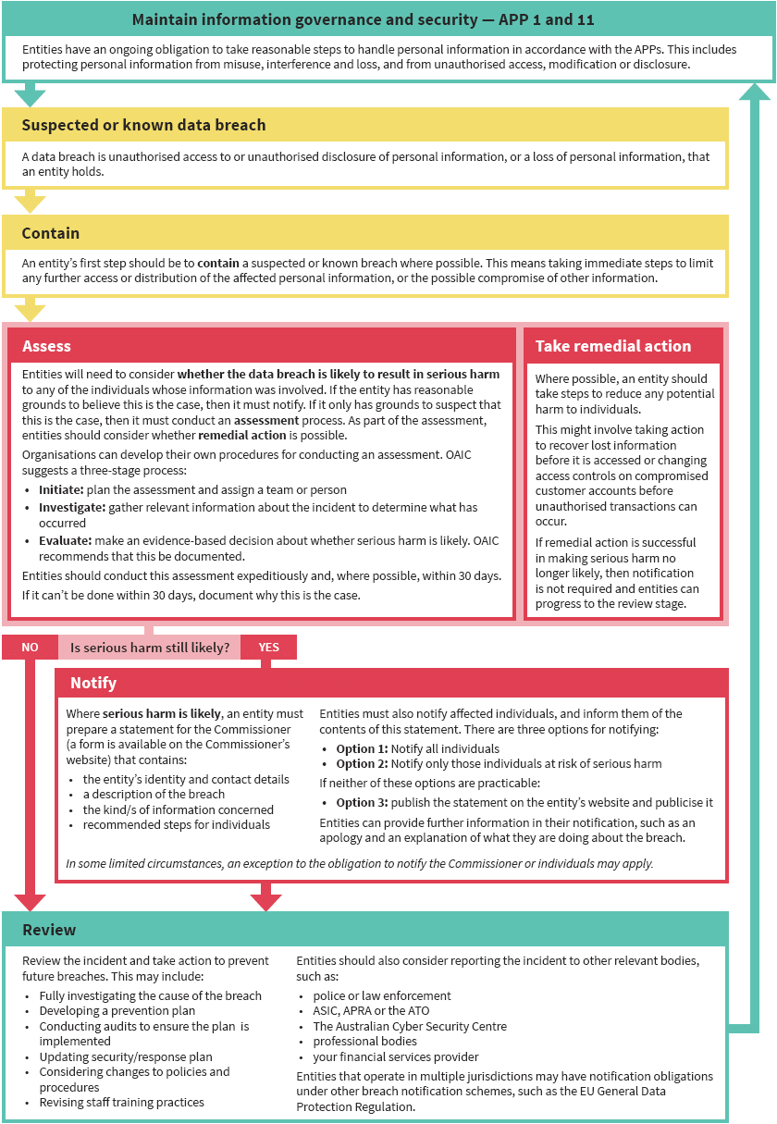
Data Breach Response Summary

Appendix B
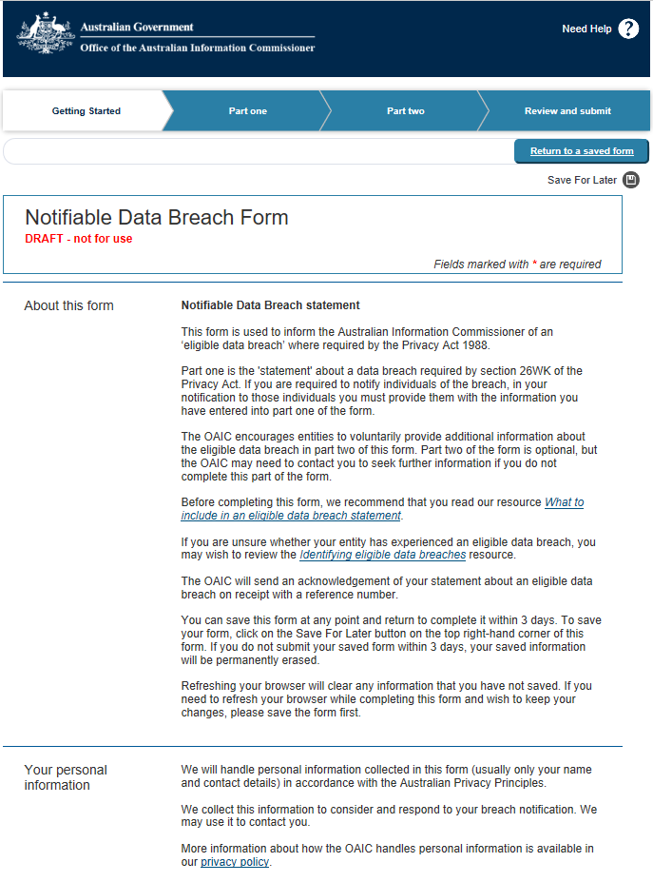
Notifiable Data Breach Form (Online)

